MANUFACTURER’S AUTHORIZATION

25th November, 2022

{{hospitalName}}
P.O.BOX MB-44
ACCRA
WHEREAS S. K. SCIENTIFIC & SURGICAL CO., LTD. who are established and reputable manufactures of Hospital furniture having factories Ambala, Haryana India I hereby authorise Drug Loft Pharmacy Limited, Dansoman Estate, 11 Odoofo Oye ST to submit a Tender, and subsequently negotiate and sign the Contract with you against The Supply of Hospital Beds and Examination Tables for the above goods manufactured by us.

We hereby extend our full guarantee and warranty as per Clause 15 of the General Conditions of Contract for the goods offered for supply by the above firm against thisinvitation for Tenders.
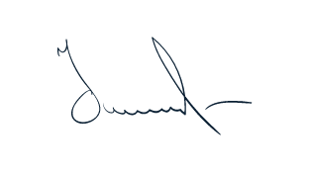

Michael Liang
Marketing Director

